34.32: 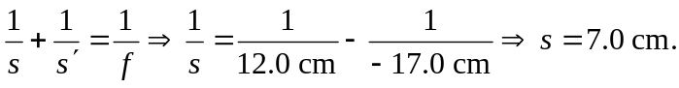
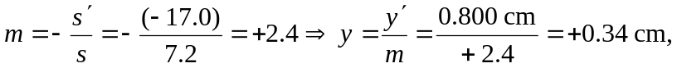so the object is
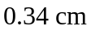tall, erect, same side.

